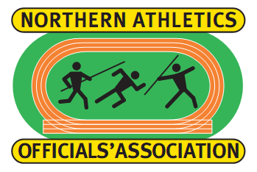

The Northern Athletics Officials’ Association (NAOA) is about friendship, assisting and educating technical officials of all disciplines and levels. Membership of the NAOA is open to any technical official supporting athletics in the North of England.
The aims of the NAOA are to:-
Act at all times in the best interests of its Members.
Encourage a high standard of officiating.
Raise the status of technical officials.
Represent the views of Members on issues affecting technical officials.
Improve the standards of facilities provided for technical officials.
Assist in the training of technical officials.

Annual Conference
The 2017 AGM and Conference, on 1st October 2017, was held at the Holiday Inn Brighouse-Bradford where our guest speaker was Peter Warden. Peter spoke about his early athletics experiences with Airedale Harriers and his international career as a 400m hurdler which took him to the 1964 Olympics in Tokyo, Japan and the 1966 Commonwealth Games in Kingston, Jamaica. Peter went on to speak about his career as a National Coach from 1981 to 1994 with anecdotes about many well known athletes that he coached during this period. The Conference again included development workshops. The next AGM and Conference will again be held at the Holiday Inn Brighouse-Bradford on Sunday 7th October 2018. Further details can be found on the England Athletics website from January 2018.

UKA Rule Book. A new rule book will be published in 2018 and will be valid from 1st April 2018 to 31st March 2020. The 2018 rule book will be issued to all Members (one copy for Joint Members) on receipt of membership payment.

NAOA subscriptions for 1st January 2018 to 31st December 2018::
Individual Membership: £10 per year.
Joint Membership (two Members at one address): £15 per year (£7.50 each).

Membership Subscriptions should be sent electronically (BACS) to the NAOA Bank Account with the TSB Bank:
Account Name: Northern Athletics Officials’ Association
Account No: 06724760
Account Sort Code: 77-71-06

Alternatively please pay your NAOA Membership Subscription, using the above, at your local TSB Branch.

As a last resort, please send cheques (made payable to “Northern Athletics Officials’ Association”) by post to:
Andy Parker (Membership Secretary), 47 Glenluce Drive, Farringdon Park, Preston, Lancashire PR1 5TD.

If you have any queries please contact Andy Parker by email at: andy.parker@blueyonder.co.uk.

Please note that it is essential that the following is completed and emailed to Andy Parker (regardless of the method of payment).

Membership Form:
I have paid my Membership fee (delete as appropriate): by BACS / by Cheque / in Cash / at Bank.

Name:
Address:
Telephone No.
Email Address:
Discipline
Current Level:
Comp. County:

