Please note: Norton College, used for parking for 2012 - 2014 has now closed, and is therefore not available for use.

We are fortunate to have again secured parking at Meadowhead school, just across Dyche Lane from Norton College. However this is an Academy school, & there will be a charge levied of £3 per car.

From Sheffield City Centre (and the north)

Follow the A61 towards Chesterfield. After passing under the railway bridge at Heeley Bottom continue for around 3 miles through Woodseats before passing Morrisons on the left and continuing to the A61/A6102 (Meadowhead) roundabout. Take 1st left and at the next roundabout take 4th exit returning on the other side of the dual carriageway. Turn left into Dyche Lane, and the entrance to Meadowhead school is on the right hand side, about 100m from the junction

From Chesterfield (and the south)
Follow the A61 towards Sheffield, when you reach the A61/A6102 (Meadowhead) roundabout take the third exit on the A6102 ring road and at the next roundabout take 4th exit returning on the other side of the dual carriageway. Turn left into Dyche Lane, and the entrance to Meadowhead school is on the right hand side, about 100m from the junction
From the M1
Leave M1 at junction 33 taking the 3rd exit A630 to Sheffield City Centre. Continue for 3 miles before leaving to follow Ring Road southbound, A6102 signposted Chesterfield and Bakewell. Continue for 5¼ miles following signs for Ring Road, Chesterfield (A61) Turn left into Dyche Lane, and the entrance to Meadowhead school is on the right hand side, about 100m from the junction
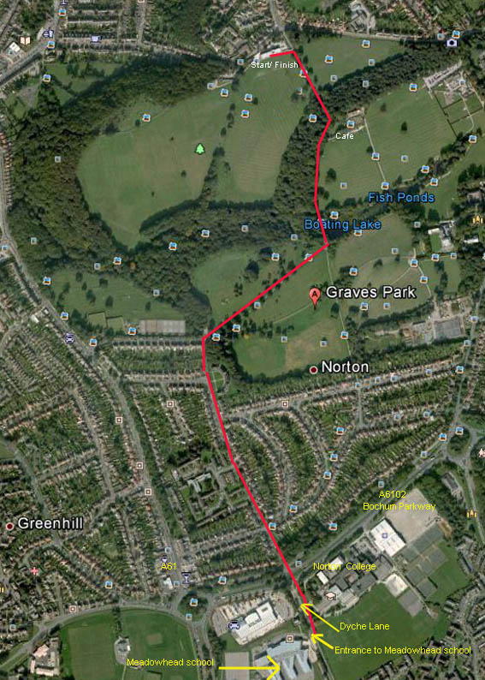 | When you enter the site, you should be directed to a parking area by parking stewards. The £3 parking fee will be requested near the site entrance. There are two parking areas; to the rhs of the entrance road there are marked parking bays, and there is a large overflow car park behind the school  Please park where directed, as there are other user allocations.  You need to walk out onto, and cross Dyche Lane – there is a footpath to the junction with the A6102.  Cross the A6102 via the pelican crossing near the Dyche Lane junction and proceed straight ahead along Little Norton lane.  The pedestrian route should be marked with black arrows on yellow background.  Follow Little Norton Lane until the road turns 90 degrees left, then follow the walkway to emerge at the park entrance.  Turn right through the park gates and follow the path to come out at the lake. Turn left, with the Lake on your right, and follow the path straight on. This climbs slightly towards the Rose Garden Café. Follow the path through the wood and descend towards the start / finish area.  Registration is in the pavilion behind the start / finish area.  To walk from the A6102 takes about 20 mins. Allow 30 mins from parking

The detailed layout below shows the way into the site, and the areas available for parking (lined in red). 2 stewards should be in attendance to guide you towards the areas. The overflow area is accessed by continuing along the access road and passing through a gate into the overflow area.

Please drive slowly through the site as pedestrians use the roads, and follow the stewards instructions. Please exit via the exit shown onto Dyche Lane

