INSTRUCTIONS FOR USING THE EXCEL RESULTS PROGRAM

- Download the spread sheet from the appropriate team managers portal well before the meeting.
For the North of England Track and Filed League this https://athletics-uk.org/noetf/

- On about the Thursday before the meeting loads up the spread sheet
You will now see the screen below

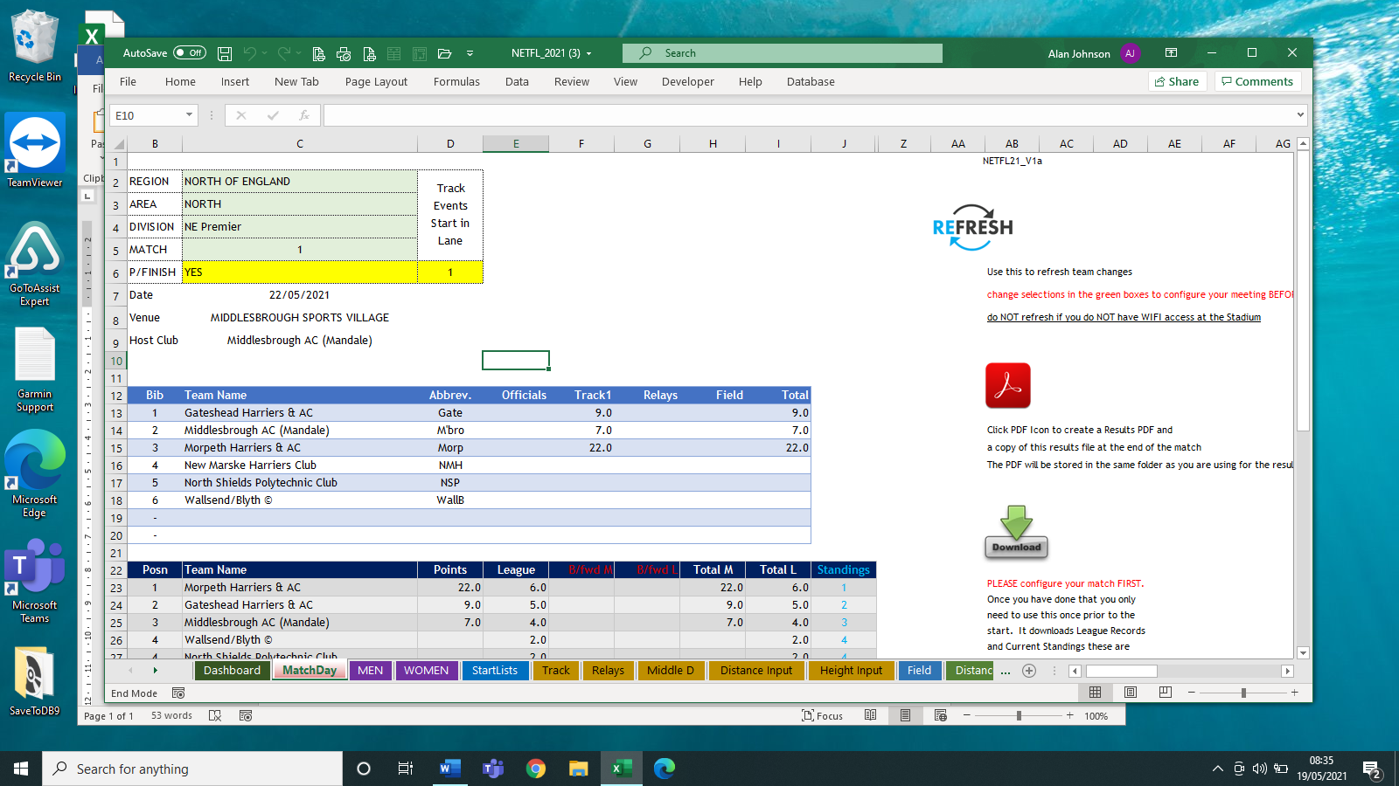

On the left-hand side is a panel for selecting your match.
- Now select Area (North, East or West)
- Now select Division
- For photofinish select YES otherwise it should be NO
- Now select download

- and you should see the team names change to your match. You don’t need to select this download again.

- Now select refresh

- This will now download all the team declarations for your match
.
- If you select tab at the bottom STARTLISTS the following screen is displayed
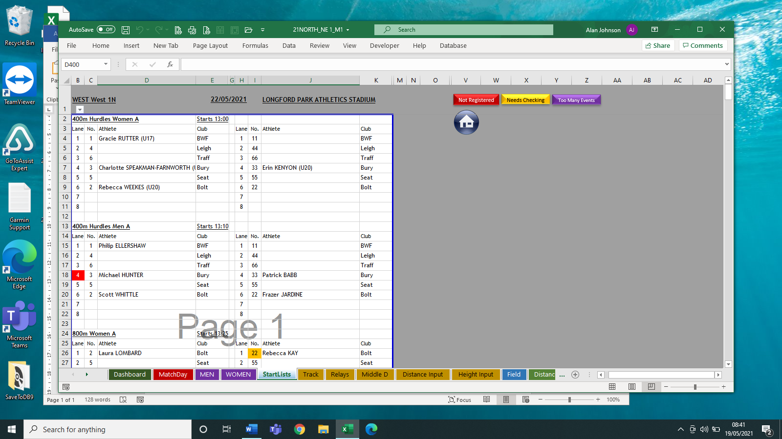

Scrolling through the lists you can see the state of each teams’ athletes.
If the lane number is in red that athlete is not registered with England Athletics and is ineligible to compete. There is time for the club to correct the error to enable that athlete to compete in the league. You need to inform the club concerned of any issues over eligibility or the divisional secretary.

If the lane number is in yellow, there are some issues over how the athlete has been entered onto the portal. The athlete is OK to compete and is just a warning to check the details. This can be pointed out on the day to the team manager. It will be a difference between the team managers portal and EA’s database. It might be a different DoB or a first name spelt differently. It is nothing for you to worry about.

If the number is in Purple, that athlete is doing too many events. This can be pointed out to team managers on the day. Do not worry about this. If it is still purple at the end of the meeting the divisional secretary will sort it out.

THAT IS ALL YOU NEED TO DO BEFORE THE MEETING OTHER THAN FAMILIARISING YOURSELF WITH THE PROGRAM

- MATCH DAY
From the Match ay Tab press the refresh button.

Throughout the meeting team managers will be making their team changes via the team managers portal. You need to keep pressing refresh on a regular basis throughout the day.
This will then update any results previously entered as well as events still to be scored.

There are no manual changes on the day. They are all done through the team managers portal

The first thing you will need to do is print off the field cards. From the initial Match Day screen above, select the DASHBOARD tab.

You will now see the screen below.

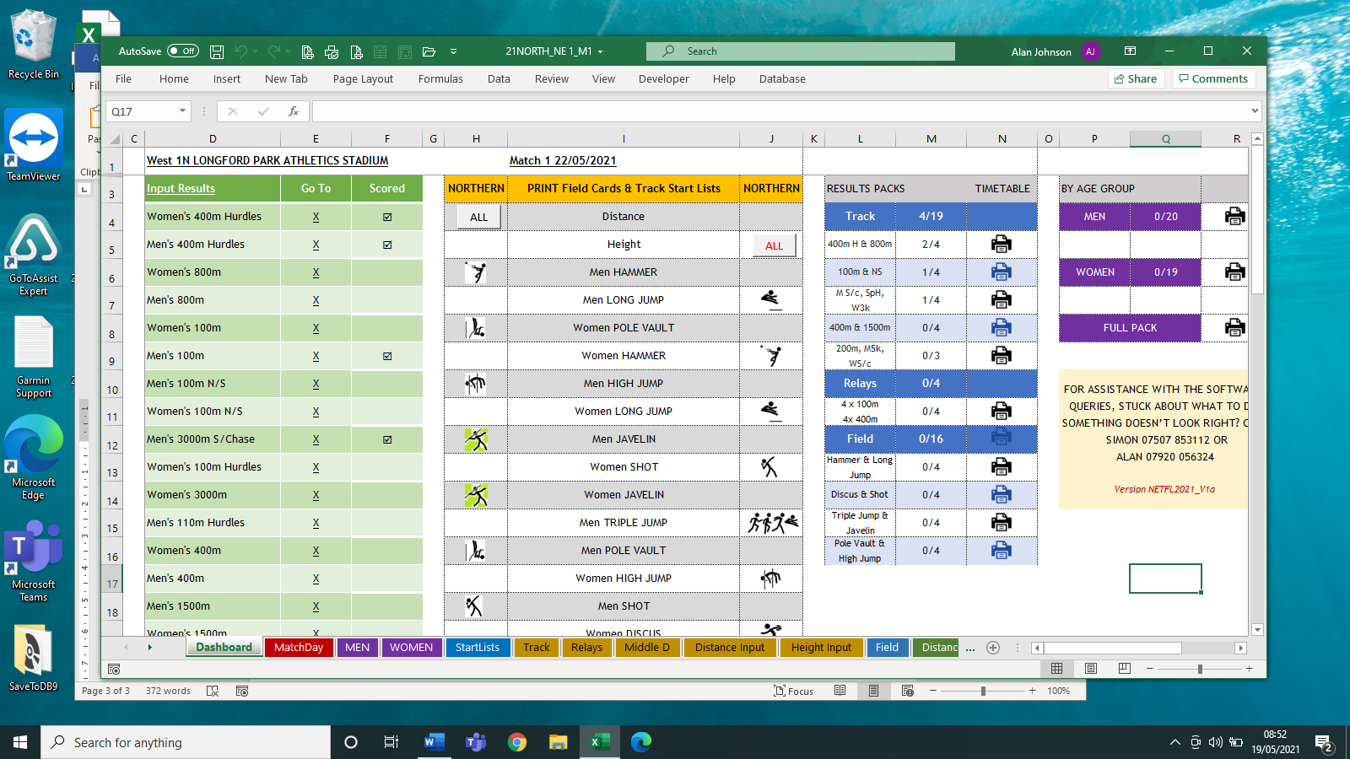

At this point, you are looking at the middle box “PRINT FIELD CARDS”

You can select to print all the cards at once by selecting the ALL buttons for height and distance or you can print each individual event as required.

- Track Start Lists. (If required)
From the STARTLISTS tab you can simply print off all the start lists at the beginning of the meeting or you can select which page to print for a specific block of events during the meeting if required.

PAGE 1 400mH & 800m
PAGE 2 100m including n/scorers
PAGE 3 3000m s/c men, 100m Hurdles, 3000m Women & 110mH
PAGE 4 400m & 1500m
PAGE 5 200m & 500m men
PAGE 6 Hammer Men, Long Jump Women, and Pole Vault
PAGE 7 Hammer Women, Long Jump Men, Discus Men & High Jump Men
PAGE 8 Shot Women, Triple Jump Women, Discus Women &Shot men
PAGE 9 Javelin Men, High Jump Women, Triple Jump Men & Javelin Women
PAGE 10 All Relays
- Entering track results (100m thru 400m). Select the TRACK tab.
For each race enter the athlete’s number and time for each position.

- Entering distance 800m. Select the TRACK tab
For each race enter the athlete’s number and time for each position.
For the time enter in the format 2.2111 which will translate to 2:11.01.
This is done to make it easier to enter the distance times.

The final results will have the times reformatted into the correct format.

- Entering distance times over 800m. Select the Middle D tab
For each race enter the athlete’s number and time for each position.
For the time enter in the format 15.2111 which will translate to 15:11.01. This is done to make it easier to enter the distance times.

NOTE: For event cancelled enter 99 in the position 1 of the A race
For event with no competitors enter 98 position 1 of the A race

If an athlete is disqualified enter DQ in the time
or if an athlete did not start once on the line enter DNS in the time.

Both DQ and DNS will be on the track slips from the track judges.

- Entering Field Events (Distance)
From Select the Distance Input Tab. The athletes will appear in the same order as the printed field card making entry easy.

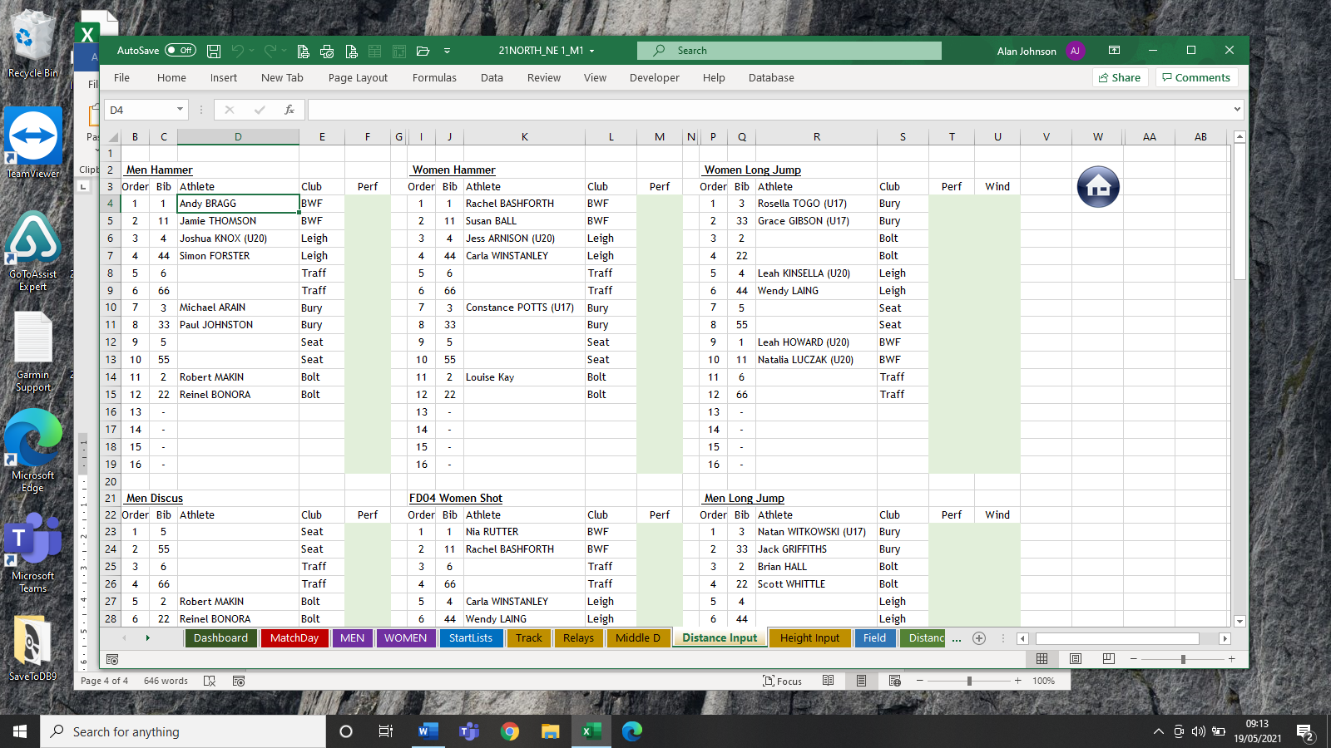

Enter each athlete’s performance in the appropriate event. Simple enough.
If an athlete has not registered a performance enter “X” in the performance column.

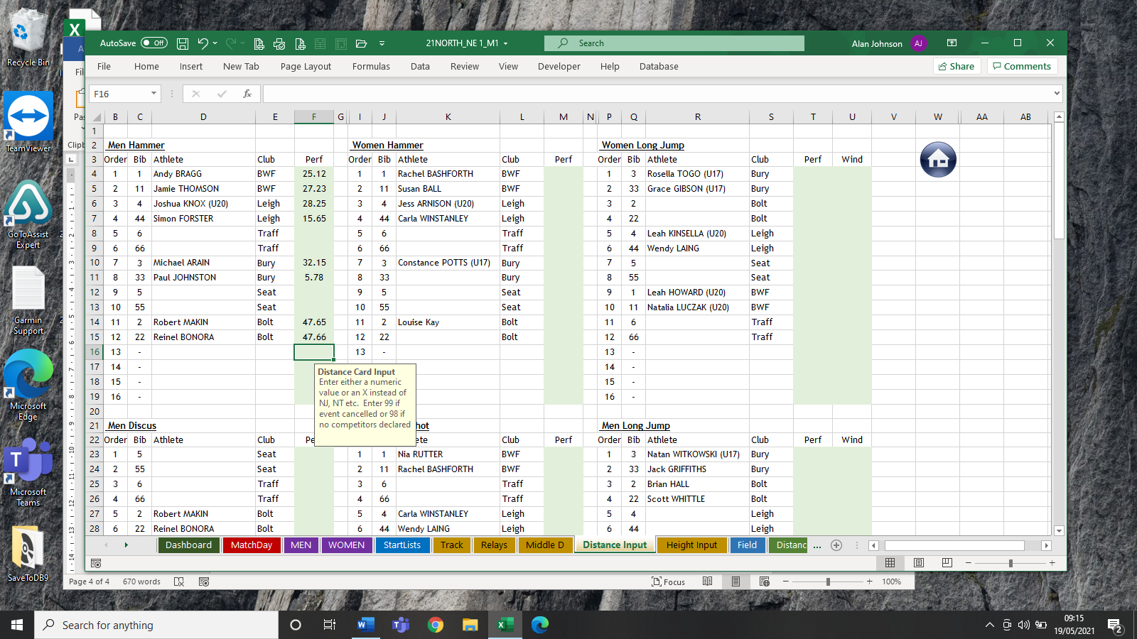

You will see from the example above how distances for the hammer have been.
You will also see a help box open up when you hover over the performances which should provide extra help. The example above is complete

What if two athletes have the same performance. Below shows you what happens
See the example below where two distances are highlighted

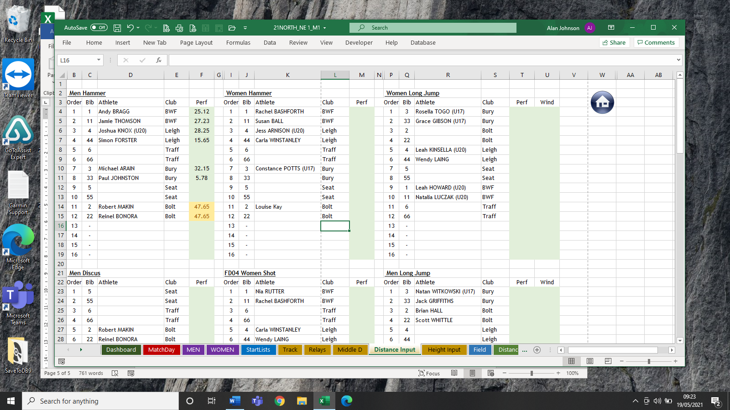

In this case you simply make the athlete who has a better 2nd or 3rd trial 47.651 which will ensure the athletes are in the correct positions.

- Entering Field Events (Height). Select the Height Input Tab

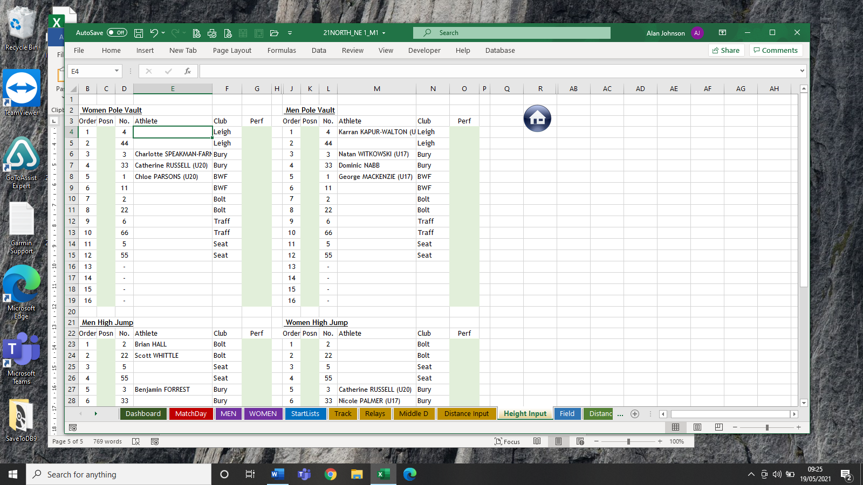

In this type of event, you need to enter the heights cleared in the appropriate column and then in the position columns the position finished in the event.

This should have been completed by the field officials before sending it to the results recorders.

Again, if an athlete no heights, enter “X” in the performance.

Obviously, in PV and HJ, you quite often get equal positions.

This is done as follows: -

If 2 athletes tied for 2nd place, the positions entered 1,2,2,4 should be entered as 1,2.1,2.2,4
If 3 athletes tied in4th place, the positions entered 1,2,3,4,4,4, should be entered as 1,2,3,4.1, 4.2, 4.3,4.4

- PRINTING OF RESULTS
All printing is done from the DASHBOARD
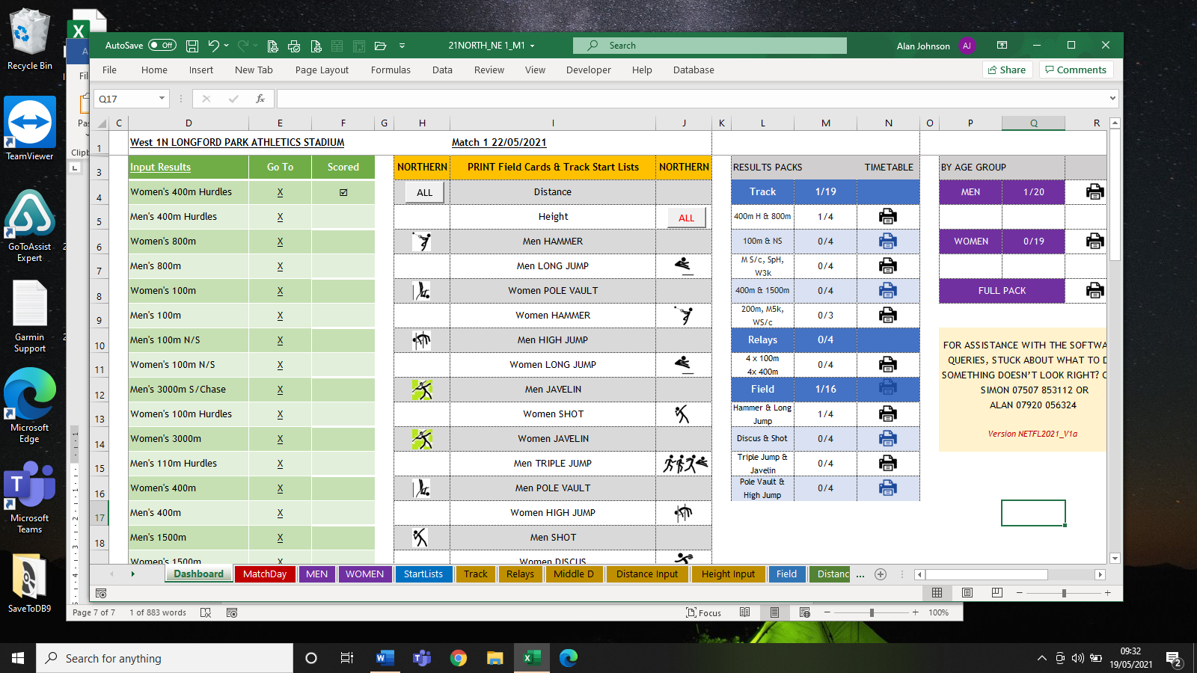

The dashboard has a wealth of uses.

The box on the left shows you when results have been entered.
You can also click on the event and it will take you to the actual result for entry.

All printing is controlled by the box on the right. Under the blue headers, Track, Relays and Field you will see events and ¼ or 0/4. These will change as results are entered.

Once you get to 4/4 all results for that event have been entered so you can now print off for displaying.

- Match Positions. Throughout them meeting you will want to print off the status of the match. If you select the Match Day tab and use the excel print option, you will get a printout showing the scores. Give this to the announcer or display.

- OTHER TABS ON THE PROGRAM
  - MEN and WOMEN This is where the final results are compiled into event order (as opposed to timetable order when entering) and separating Male from Female.
  - Distance. These are where the distance card prints come from
  - Height. These are where the height cards come from

ASSISTANCE

For any help during the day telephone Alan Johnson on 07920 056324

