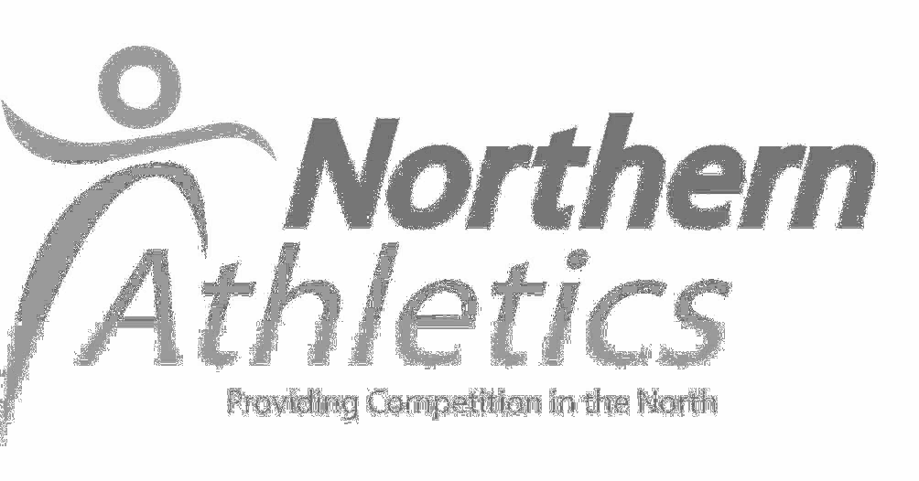

NORTHERN ATHLETICS
‘START FITNESS’ INDOOR OPEN TRACK & FIELD MEETING
at the
ENGLISH INSTITUTE of SPORT, SHEFFIELD

Saturday 20th November 2021

First Event – 10.15

We anticipate a high level of interest in these events and reserve the right to return entries if limits are exceeded. **Although some entries may be available on the day, athletes are advised to enter prior to the competition day to avoid disappointment and assist with management of the meeting. Information on closure of events will be published on our website in the week before the event.

Events (Senior): 60m, 150m, 1000m, 2000m, Shot, Pole Vault, Triple Jump
Events (Under 15): 60m, 600m, 1000m, Long Jump, Shot, Pole Vault

Senior, U20 and U17 track competitors will be seeded together by ability as one competition at call-up. U15 and U13 age groups will be seeded together.

Competitors will have four trials in Long Jump, Triple Jump & Shot.

Age Groups: Track & Field age groups as at 31 August 2022.

ENTRY FEE: £8 per event.
Entries and start lists will be published online at www.northernathletics.co.uk and race- results.co.uk Collect numbers on the day. Sheffield Events will charge a car parking fee of £5 which will not benefit Northern Athletics.
An Order of Events and other information will be posted on the NA website (www.northernathletics.co.uk and facebook).

Entries : Online only at www.race-results.co.uk

Enquiries: Telephone 01924 457922: e-mail northernath@btconnect.com

Sheffield Events will still have some Covid regulations in place. EIS have requested that masks should be worn when moving around the venue and social distancing observed at all times.

Sanitisers will be situated around the venue – please sanitise your hands frequently. Updates and/or changes to Covid protocols from the venue will be circulated if necessary.

