NORTH OF ENGLAND TRACK AND FIELD LEAGUE
TEAM MANAGER’S PORTAL

The following screen shots and explanations will guide you through the initial part of the team manager’s portal.
The link to the portal is
https://athletics-uk.org/noetf/
The initial screen displayed is
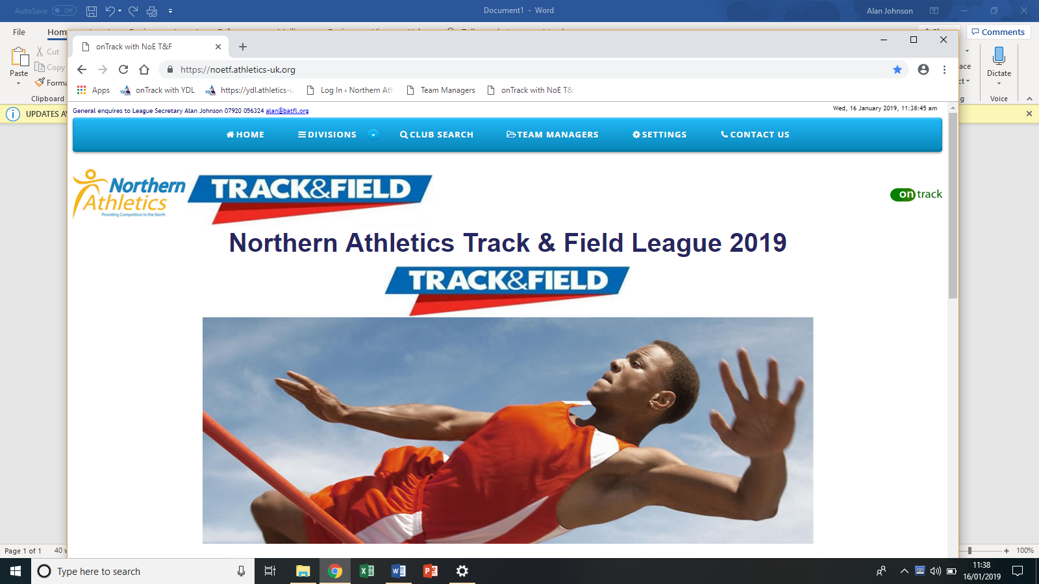
The option to select is Team Manager.
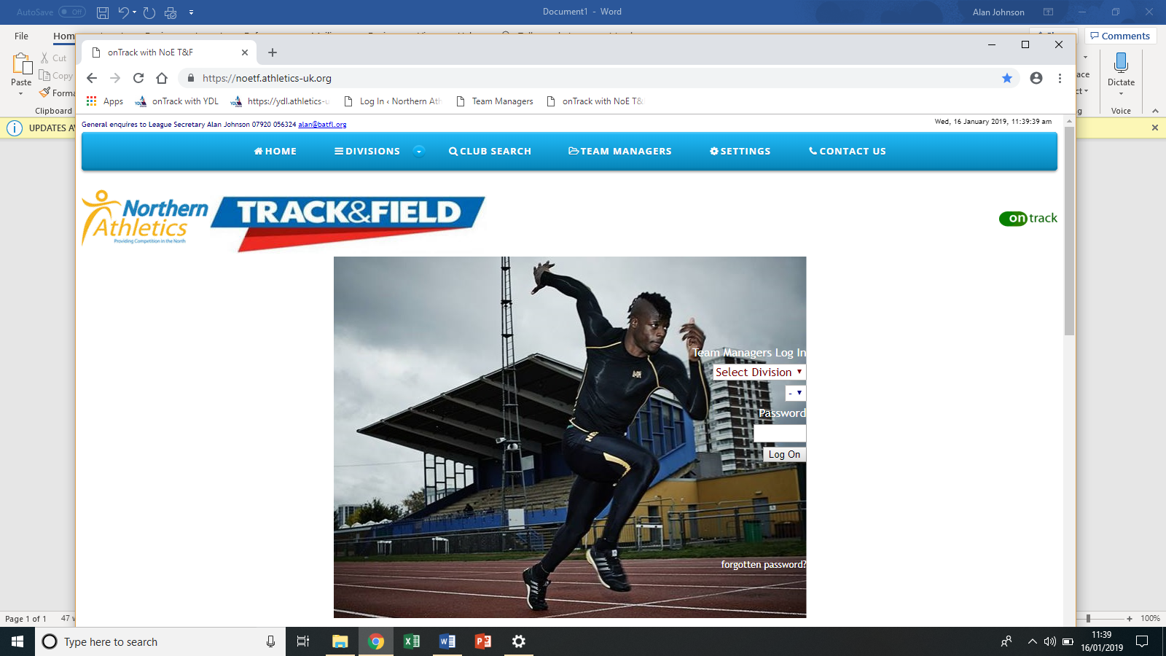.
You know need to choose from the drop-down menu your division, then your team and then enter your password. Passwords will be supplied directly to each club either by Simon Fennell or myself. For those teams which have a YDL password, the passwords will remain the same.

You will now be presented with the following screen
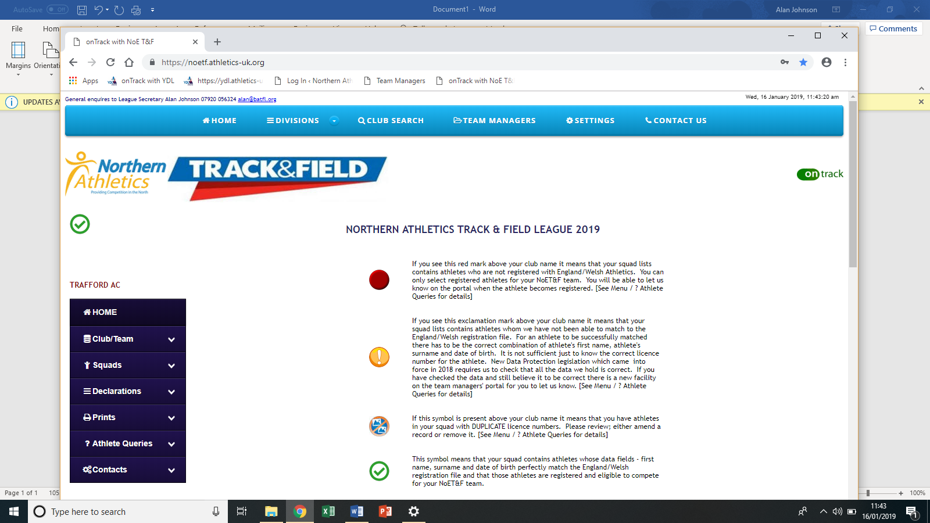
Select the CLUB/TEAM options will display
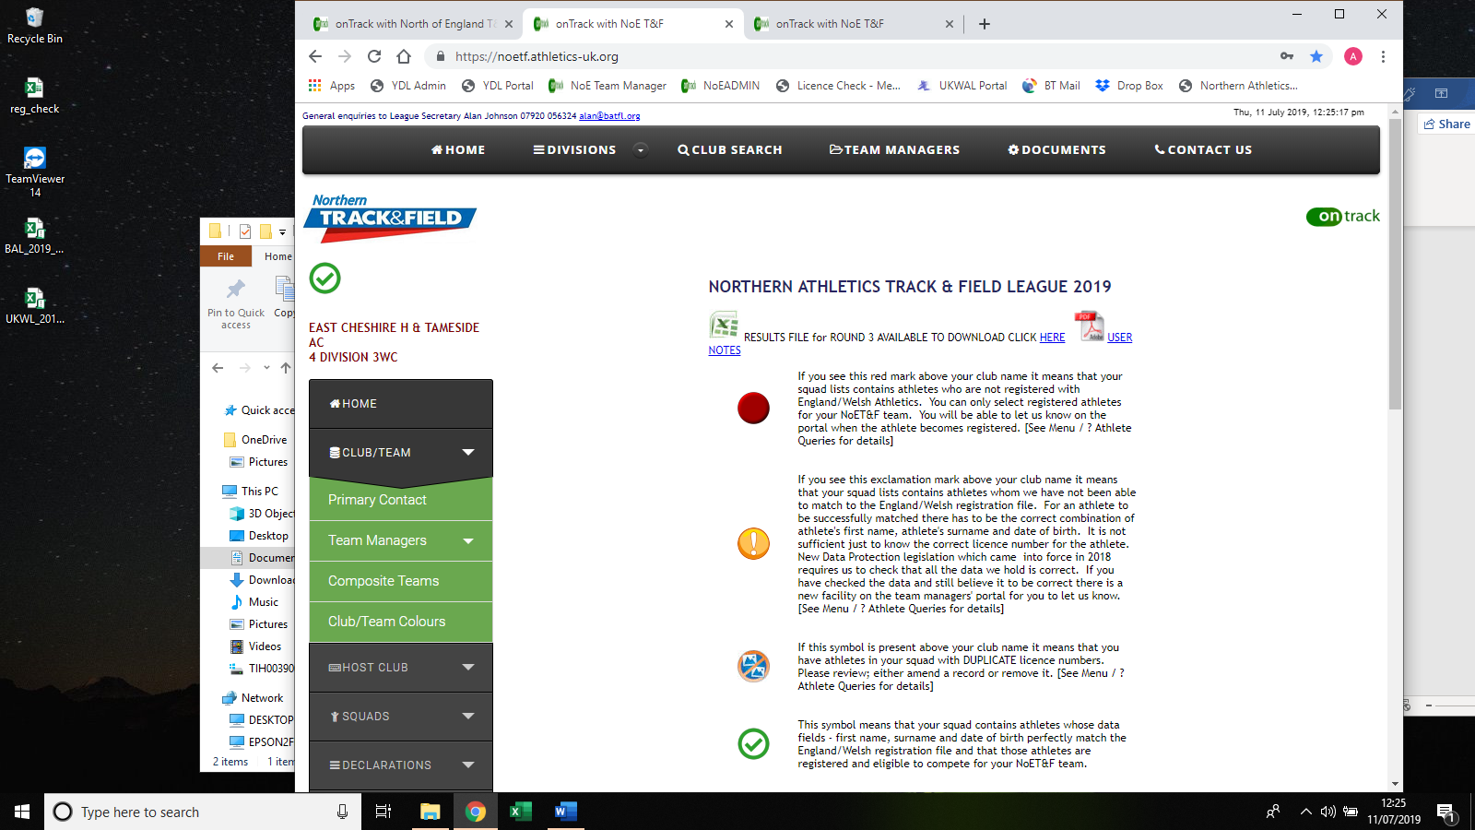
Select Team Managers and you can view and Appoint team managers and View/Edit
Use this so that the league has an idea who to contact
For host clubs they should enter details of the match scorer. This will enable the league to contact the scorer direct if there any issues.
Clicking on Officials attending will display all declared officials for your match from the other teams.
If you are hosting and the display says you are NOT a host club, please contact the league secretary.

Click on the SQUAD Tab
Clicking on this display
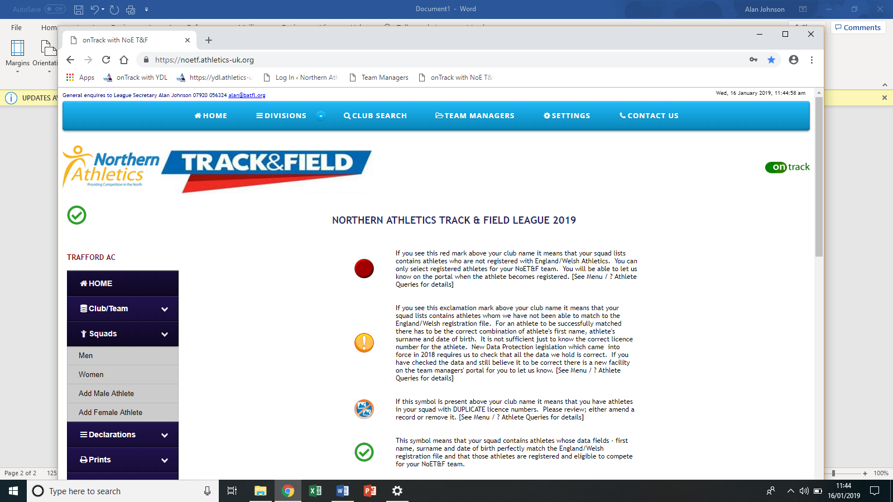
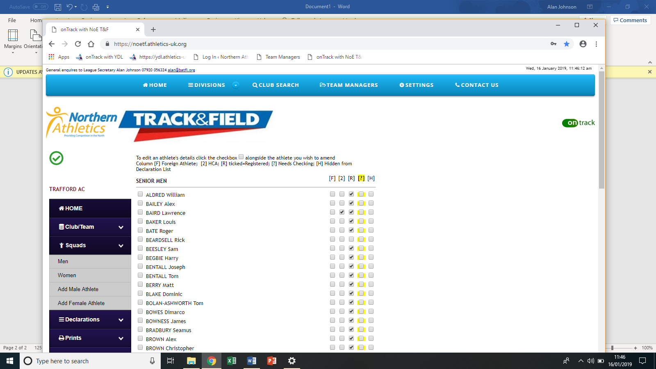
This screen shows all male athletes at your disposal.
At this point you can see the eligibility of these athletes.
If they have the 3rd column ticked headed [R] they are eligible to compete.
Any other ticks need investigating. As this is still in development you will also see any 2nd claim athletes who may have been used in the YDL teams. These will eventually not show. Similarly, with HCA athletes.
Could you look through these athletes are where necessary delete if they are no longer applicable.
To do this simply click on the box to the left of the athlete’s name and on the right-hand side you will see
DELETE ALTOGETHER

Click on the x and confirm. This will remove the athlete from your team squad.

To Add an athlete
Lick on add male or female athlete

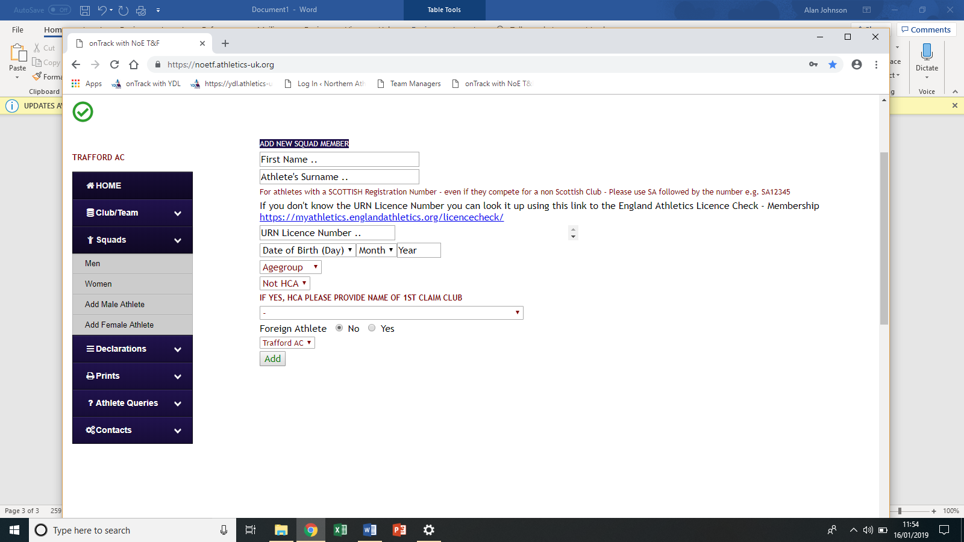

Enter the details accordingly. Note that these should be exactly as was entered on the England Athletics Database by your club’s membership secretary. It is vital that all applicable fields are completed correctly.
At this point, the eligibility will have to be checked and updated by the administration people of the league. Eventually, it will auto check the EA database and give an immediate answer to the question of eligibility. If the athlete isn’t registered the onus is on your club to inform the league when the athlete becomes eligible to enable us to update your athletes’ details.

The instructions above are to allow you to get your teams squads updated for the forthcoming season.
Throughout the seson add and delete athletes as required.

DECLARATIONS
Select the DECLARTIONS OPTION
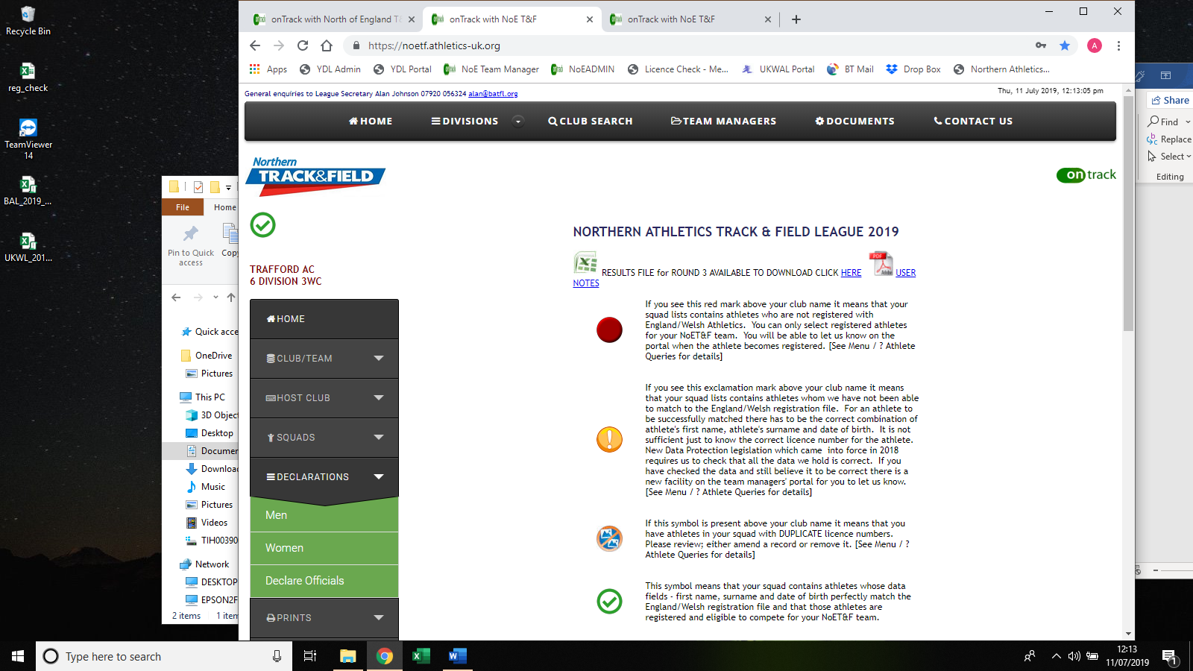
Yoru can now declare your teams and officials here.
Please note when entering officials details you enter all details where possible. The officials area is free format.
For team declarations the screen will look like
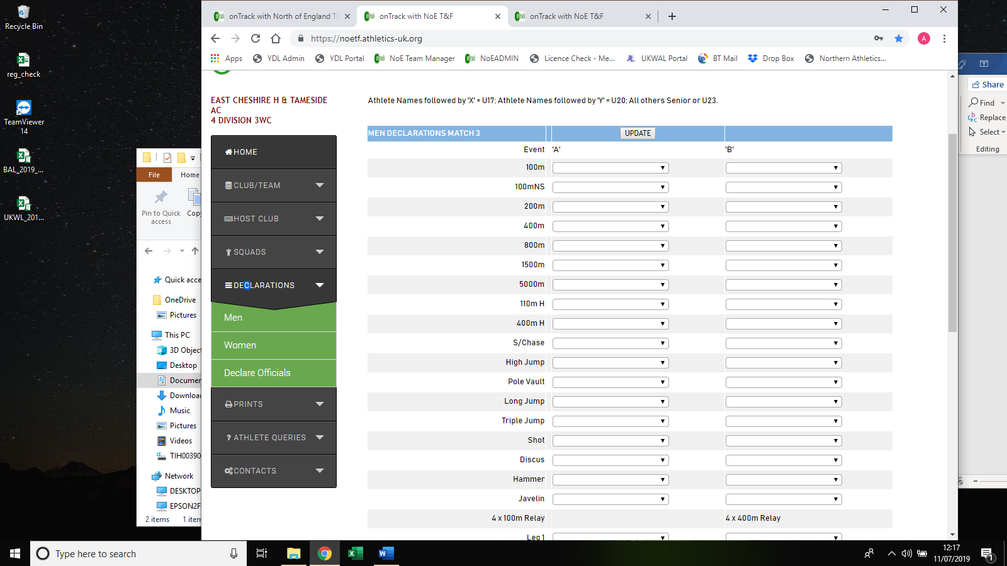
Clicking on the downward arrows will list the athletes you can select from.
When complete, do not forget to press UPDATE at the top of the form otherwise you lose everything you have entered. Between matches the screen will go blank about 10 days before the fixture/ At that point you can then enter your teams
PRINTING
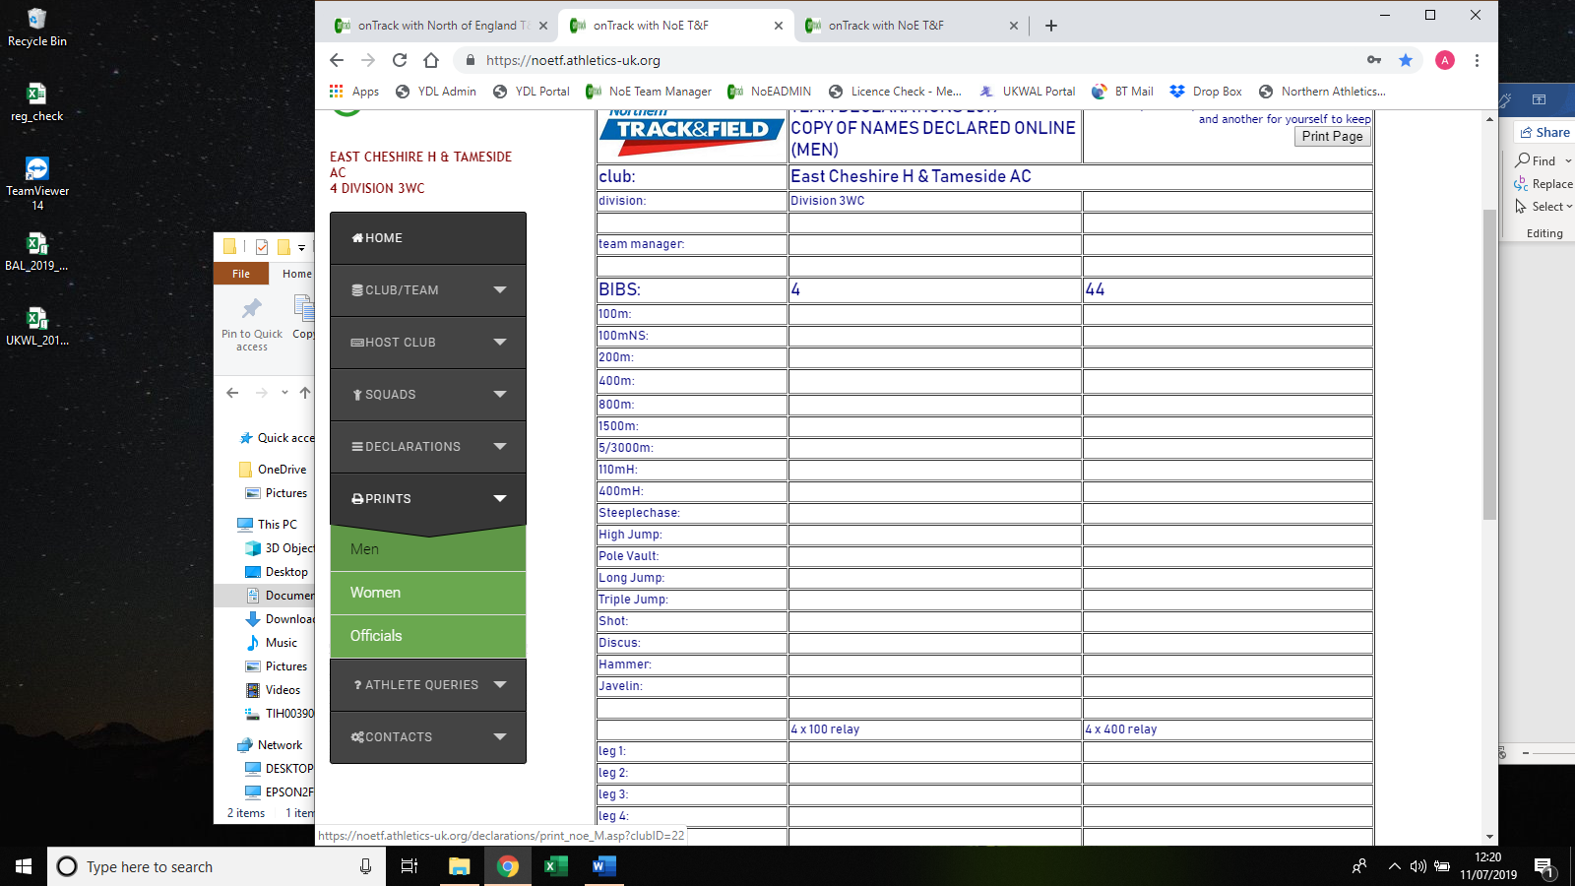
Select PRINTS and then MEN gives you the screen above which will contain all your declared athletes.
To print this out select “Print Page” in the top right hand box.
Do the same for Women and officials.

Athlete Queries and Host Club Contacts will be updated later.

